**DIT 637 Smart and Secure Systems**

**TT01: Experiencing Cloud Computing – Full-Stack Web Application**

6/14/2024 Developed by Clark Ngo

6/19/2024 Reviewed by Sam Chung

07/30/2025 Reviewed by Rajdeep Singh Golan

School of Technology & Computing (STC) @ City University of Seattle (CityU)

**Key Concepts and Tools for Web Development**

* **Frontend**: To create the visual part of websites and applications that users interact with, like the layout of an e-commerce site.
* **React**: To efficiently build dynamic and responsive user interfaces, such as the interactive components of Facebook.
* **Movie Search**: To practice and demonstrate the capabilities of React in creating real-world applications, like searching for movies on Netflix.
* **Codespaces**: To provide a cloud-based development environment that's easy to set up and use from anywhere, similar to Google Docs but for coding.
* **GitHub as Repo**: To store and manage code with version control, making collaboration easier, just like using Google Drive for sharing documents.

### **User Case – Movie List Display & Search**

💡 *A user story helps by clearly defining the user's needs and goals, ensuring that development efforts are focused on delivering value to the end-user.*

**As a** movie enthusiast, **I want to** search and browse a list of movies with details such as title, genre, and year, **so that I can** easily find information about movies I am interested in.

### **Features Included**

1. **Movie List Display**:
   * **What**: Shows a list of movies with their titles, genres, and release years.
   * **Why**: To provide users with a comprehensive view of available movies.
2. **Search Functionality**:
   * **What**: An input field that filters the movie list based on the user's search term.
   * **Why**: Allows users to quickly find specific movies by typing part of the title.

### **Flow of Interaction**

1. **Initial View**:
   * The user sees a list of all available movies along with a search bar at the top.
2. **Using the Search Bar**:
   * As the user types into the search bar, the list of movies dynamically updates to show only those that match the search term.

### **Technical Implementation**

* **State Management**: Uses React's useState hook to manage the search term and filtered movie list.
* **Search Handling**: Updates the displayed movie list in real-time based on user input.
* **Styling**: Utilizes Material-UI components and custom styles for a clean and responsive user interface.

This user story ensures that users have a seamless and interactive experience when searching and discovering movies in the application.

### **Setup**

1. Open the project in GitHub.
2. Create a cloud-based development project with GitHub Codespaces:
   1. 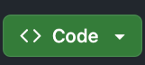
   2. 
   3. 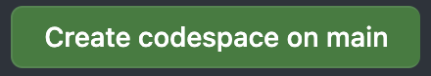
3. In the terminal type:
   1. npm install
   2. npm start
4. It should automatically open a new browser (If prompted, click “Retry”)

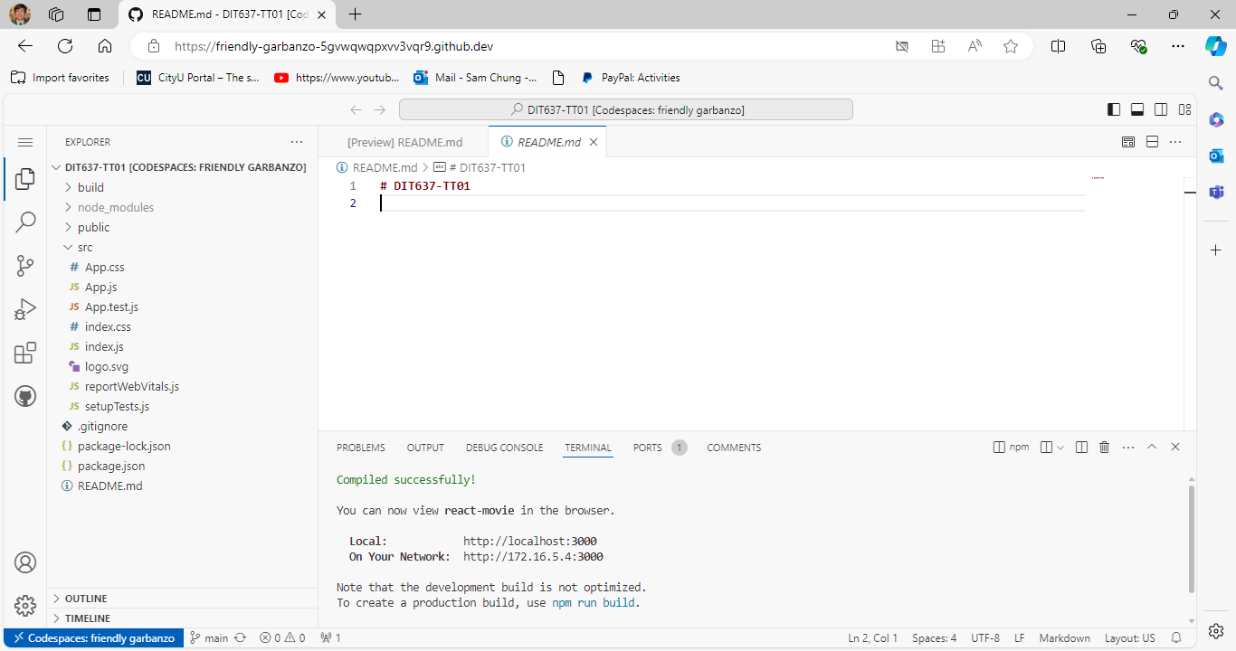

### **Screenshot Summary**

In the provided screenshot, we see:

1. **Movie List Title**: Displayed using Typography with the variant "h4".
2. **Search Bar**: A TextField at the top for users to type in their search queries.
3. **Movie Items**: Each movie is displayed in a ListItem, showing the title, genre, and year.
4. **Separation**: Each movie item is visually separated by a border, providing a clean layout.

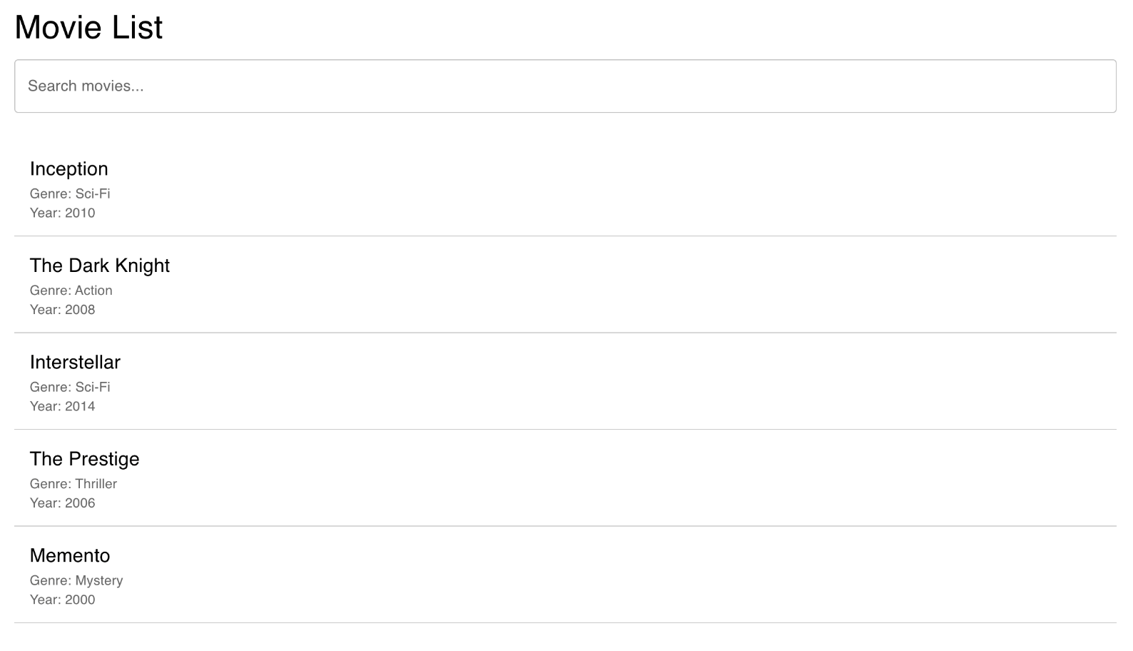

Take the screenshot of your ‘React App’ as ‘firstname_lastname_react_app.png’ by using your first and last name and upload/push to current GitHub repository.

### **Components Overview**

1. **App Component**:
   * The main component that contains the entire application structure.
   * It maintains the state for the movie list and search term.
   * It renders the movie list and search input.
2. **Container (Material-UI)**:
   * Wraps the entire content to provide consistent spacing and layout.
   * Styled using styled from Material-UI's system for custom styling.
3. **Typography (Material-UI)**:
   * Used for consistent text styling.
   * Here, it is used to display the title "Movie List" and movie details.
4. **TextField (Material-UI)**:
   * An input field for searching movies.
   * It updates the search term state and filters the movie list based on the input.
   * Styled using styled from Material-UI's system.
5. **List (Material-UI)**:
   * A container for the list of movies.
   * It ensures the movies are displayed as a list.
6. **ListItem (Material-UI)**:
   * Represents each movie in the list.
   * Styled using styled from Material-UI's system for custom borders and layout.
7. **ListItemText (Material-UI)**:
   * Displays the movie title, genre, and year within each ListItem.
   * Uses Typography for consistent text styling.

### **Code Overview**

This code imports necessary React hooks and Material-UI components for building and styling the movie list application. The following code is present under **src/App.js**

* **React Hooks**: Enable functional components to use state and other React features, making the code more concise and easier to manage.
  + **Functional Components:** Simplified React components defined as functions, offering a more concise syntax and easier testing compared to class components.
  + **State in React:** A built-in object for managing component-specific data that can trigger re-rendering when updated, enabling dynamic and interactive UIs.
* **Material-UI**: Provides a comprehensive set of components and styling tools to create a responsive and visually appealing user interface efficiently.



**Sample Data for Movies**: Provides a predefined list of movies with their titles, genres, and release years, used to populate the initial movie list and demonstrate search functionality.

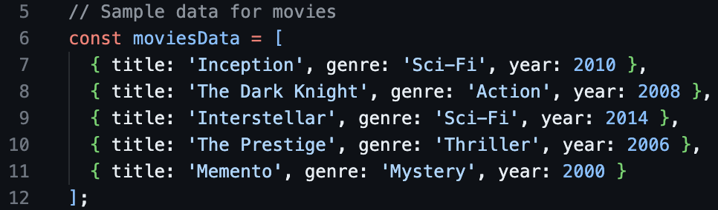

**Styled Components Using Material-UI**: Enhance the appearance and layout of the React application by adding custom styles to Material-UI components, ensuring a consistent and visually appealing design.

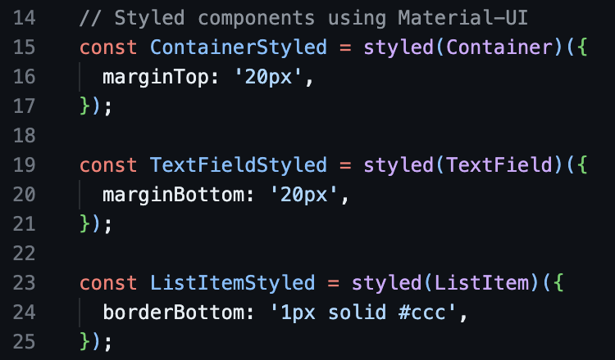

**App Component**: The main functional component that uses state to manage the search term and movie list, providing real-time filtering and rendering of movie data to create an interactive user interface.

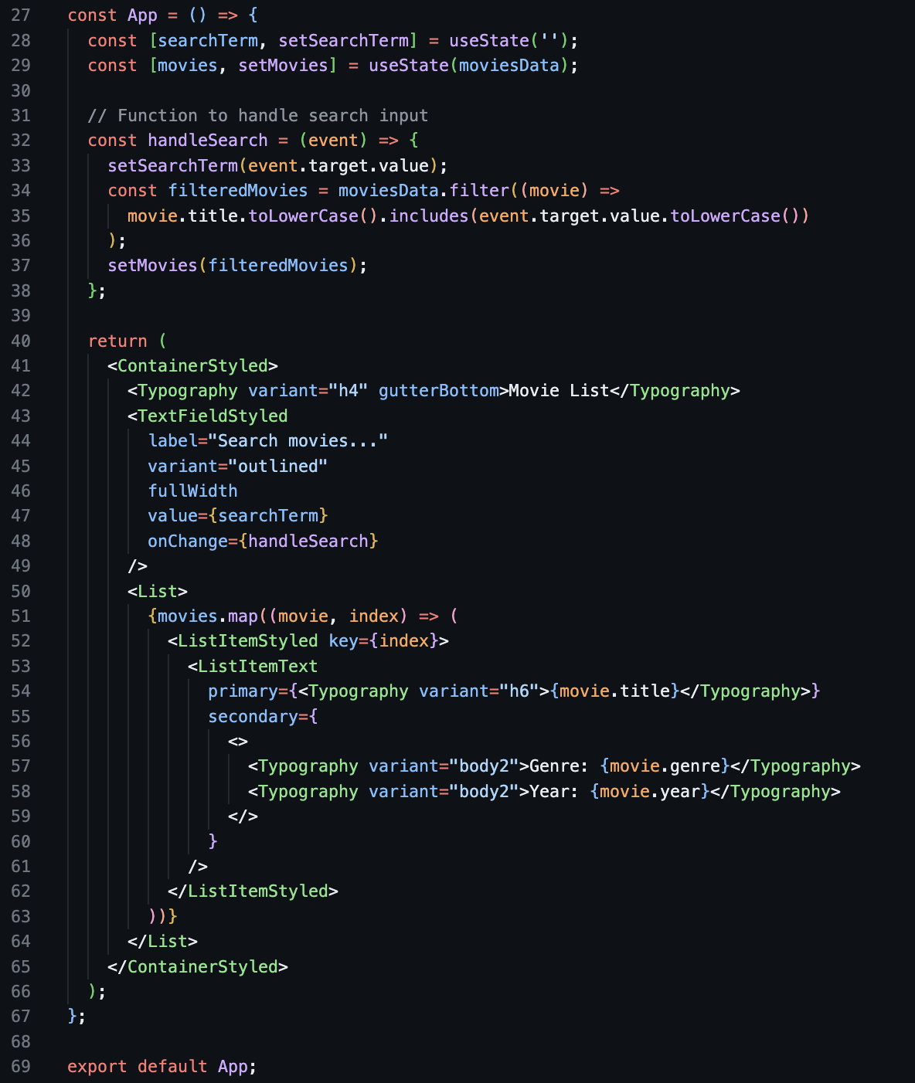

### **Breakdown:**

**App Component Definition**:



* **What**: Defines the main functional component of the application.
* **Why**: Serves as the entry point for rendering the user interface.

**State Declarations**:



* **What**: Declares state variables for managing the search term and movie list.
* **Why**: Enables dynamic updates and re-rendering when the search term changes or the movie list is filtered.

**Handle Search Function**:



* **What**: Function to update the search term and filter the movie list based on user input.
* **Why**: Provides real-time search functionality, allowing users to find movies by title.

**Render Method**:



* **What**: Renders the search input, movie list, and individual movie details.
* **Why**: Displays the user interface elements and ensures they update dynamically based on the search term and movie list state.

**Export Default App**:



* **What**: Exports the App component as the default export.
* **Why**: Allows the App component to be imported and used in other parts of the application.